# Attributes in HTML

**Program:**

<html>

<head>

<title>Login Form</title>

</head>

<body>

<h1>Form</h1>

<form>

<label for=fname>First Name :</label>

<input type="text" name="fname"/><br><br>

<label for=lname>Last Name :</label>

<input type="text" name="lname"/><br><br>

<label for=email>E Mail :</label>

<input type="text" name="email" size="30"><br><br>

<label for=pwd>Password :</label>

<input type="text" name="pwd"><br><br>

<label for=Gender>Gender :</label>

<input type="radio" name="Gender" value="Male"/>Male

<input type="radio" name="Gender" value="Female"/>Female<br><br>

<label for=yos >Year of Study :</label>

<select name="Year of Study" style="width: 150px">

<option value="I YEAR" selected>I YEAR</option>

<option value="II YEAR">II YEAR</option>

<option value="III YEAR">III YEAR</option>

<option value="IV YEAR">IV YEAR</option>

</select><br><br>

<label for=Sskill>Soft Skills :</label><br>

<input type="checkbox" name="sskill" >Leadership Skills<br>

<input type="checkbox" name="sskill" >Communication Skills<br>

<input type="checkbox" name="sskill" >Problem-Solving Skills<br>

<input type="checkbox" name="sskill" >Interpersonal Skills<br>

<input type="checkbox" name="sskill" >Teamwork<br><br>

<label for=remarks>Type Your Remarks :</label><br>

<textarea cols="50" rows="5" value="remarks">

</textarea><br><br>

<input type="submit" value="Submit">

<input type="reset" value="Reset">

</form>

</body>

</html>

# Output:

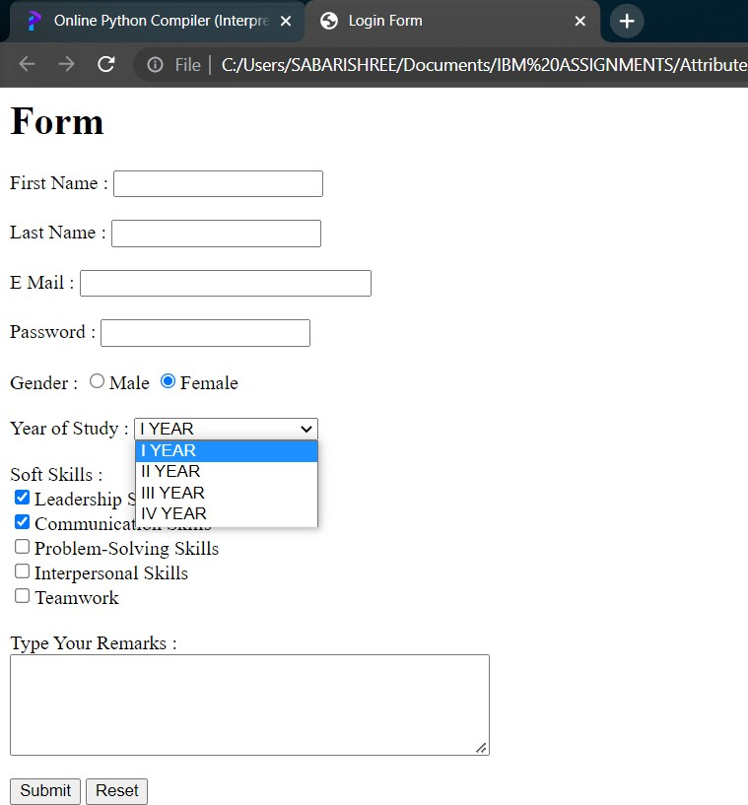

Submitted by

Yogesh P

Sunil I

Mahalingam M

Sridevi M I

Vishnu Murugan